**Conversation Guide: Digital Health Modernization Discovery Research**

**Bold text identify the moderator’s questions.**

*Text in italics are Jen’s observations and interpretations of the participant.*

[Text in brackets are interpretations in participants’ direct quote.]

**Background (5 minutes)**

To get started, I’d like to get a little background information about you, and your experience with the VA.

1. **Can you tell me a little bit about yourself?**

I started active during in 1968 and retired in 1993.

I was healthy in 1993 so I didn’t pay attention to the VA so therefore the transfer of records from active duty to the VA didn’t go very well.

Then around 2010 or so I realized I could get hearing aids from the VA so that was the real start of contact with the VA. I did manage get hearing aids.

In 2011 I was diagnosed with prostate cancer but I didn’t really pay attention to the impact that had to the VA. I was using Walter Reed and then Bethesda for the cancer issues.

About 2017, I decided to apply for disability for the prostate cancer due to it being related to Vietnam. My original attempt was rejected because my DD2-14 didn’t show I was in Vietnam. This happened with my brother as well, we were both TDY, Temporary Duty there. So my older brother was there in the 60s I was there in 1969. I had my TDY orders so I appealed the first rejection and showed them the proof I was there and it came through to get disability due to it based on the presumption that prostate cancer was related to Vietnam even if it were only for one day.

**What do you mean by presumptive case:**

As a result of Agent Orange usage, there is a list of I am going to guess presumptive 13 illnesses that are presumed that if you have that illness and were there for a minimum of 1 day it is caused by being in Vietnam.

1. **What VA benefits do you receive?**

Hearing aids, disability claim, eyeglasses.

**Used other housing or education through VA**:

No.

1. **You mentioned Walter Reed. Are you using the VA as your primary healthcare:**

No, it is much easier to use Medicare and go to local facilities.

1. **Do you have any family members who you claim as dependents?**

I have my wife, that’s all.

**4.a. Do your family members receive any benefits from the VA?**

No.

For full information I also get DIC [Dependency and Indemnity Compensation] because of my late wife that was retired from the Air Force as well. She had cancer and I get compensation as a result of her death.

1. **Do you manage any of your VA benefits online?**

*Participant thinks for several seconds.*

Hmmm.

*Participant thinks for several seconds.*

Um, I cant think of any.

I have had a video call from a GP in the VA. Once a year he contacts me and I have gotten some lab tests as a result. That essentially the annual wellness visit is completed. The doctor calls me from the VA to take care of it.

This last year with COVID has been a challenge with eye glass and hearing aids because the VA clinic at Fort Meade hasn’t been doing anything in person. I am not sure if they can do eye visit on video yet.

**5.a. For your lab tests do you remember what website you were using or how you received those?**

It has been awhile actually. I am trying to think.

In 2019 I physically went to the doctor at Fort Meade they took blood tests there. So I don’t remember.

The VA every year contacts me to set up an appointment where I go and get checked if I still have prostate cancer. They arrange for appointments to go see a contractor I think for the VA and frequently it’s in Virginia, so I travel to Virginia to have the meetings and a PSA [prostate specific antigen] test done. That has been in person though. During COIVD I don’t remember that taking place.

**Why do they call to check on you yearly:**

They are giving me a substantial amount of money, and I am confident that they don’t want to if its not due.

In the prostate world I have been in a wait and see program. Watchful waiting is another term. That’s when your Gleason Score is as low as possible. It has a low score so you wait to see if the score goes up. If your PSA goes up. If nothing happens you just continue. If the prostate becomes active and they were to remove it, in theory I could become cured.

And so then if I am cured there would be no reason for me to I should not be getting the DIC from the VA. It is one of those weird things, it is unfortunate to have been identified with prostate but fortunate to be identified with the lowest identification possible.

They check each year to see if it has changed at all.

1. **Do you use any mobile apps to manage your health?**

Sure, there’s a number.

One of the problems every doctor seems to have a different mobile app with their records.

I have an iPhone and most of my doctors associated with an app called MyChart.

**Are these the doctors you receive through Medicaid?**

Yes, they are civilian doctors.

*Moderator shares screen of VA.gov.*

1. **Have you seen this or used this website before:**

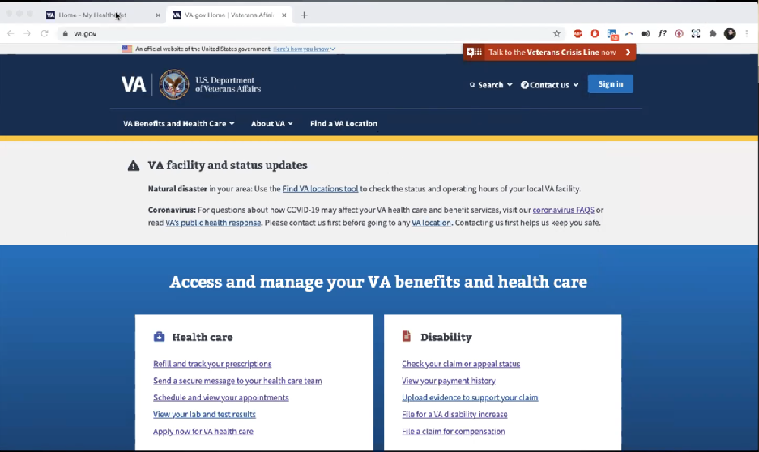

*Moderator shows [va.gov](http://va.gov) website.*

Yes I have gone to the VA, uh my ehealth, or eheath vet, or whatever it is I’ve been there. *Moderator is not showing My HeatheVet website, but the* [va.gov](http://va.gov) *site.*

*Moderator opens My HealtheVet site in new tab.*

**Does it look like this:**

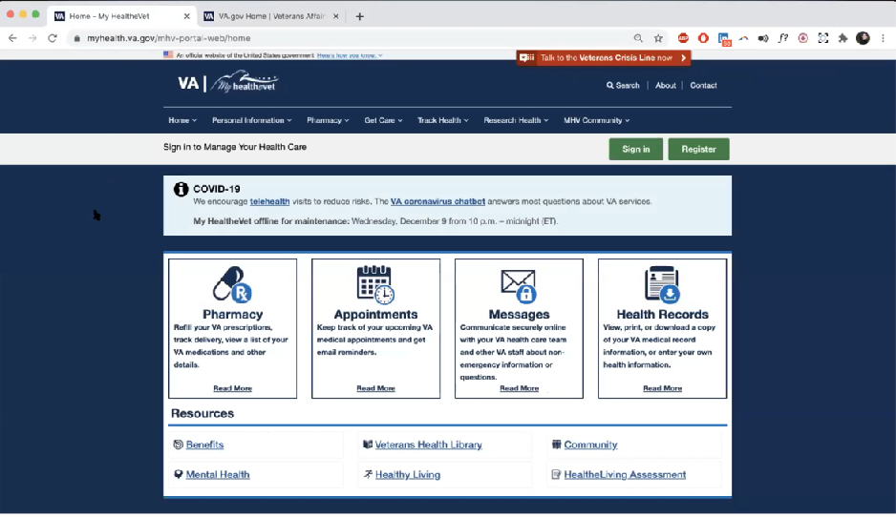

*Moderator shows [myhealth.va.gov](http://myhealth.va.gov) website.*

*Participant pauses for several seconds*

Yes I’ve seen this.

**Do you remember what you have done on this website [My HealtheVet]:**

I think I have opened my health records so they could be shared between the VA and my local doctors.

**Mental model of health at the VA (20 minutes)**

Now I’d like to hear about your experience transitioning from the military to the VA. **(10 minutes)**

1. **How did you learn about the health care available to you through the VA?**

That was really it because we had monthly lunch-ins with a bunch of retired officers I know and someone mentioned you could get glasses from the VA so I investigated.

The first thing that happened was the hearing aids, once you start with the VA then you can get more and more medical benefits. So having gotten the hearing aids in that case I needed to prove when I was retired from the Air Force. The retirement records didn’t transfer really well but I had my own personal copies showing that my hearing was degraded while on active duty so they started to provide medical benefit and hearing aids and that was the start of entering the VA system.

1. **What was the process like:**

I would have to go back and research that was 10 years ago.

I started with hearing aids in about 2005 and went through two sets of civilian hearing aids and spent 10k on them then somehow I don’t know if it were advertising I heard that VA would provide hearing aids.

I would need to spend time thinking about or look at records to remember exactly how I got to the VA.

1. **Do you remember if it was an application online or on paper:**

*Participants wife starts talking off screen.*

I think it started when we found about your cancer they talked about everything that you were entitled to and we filled out paperwork [from wife].

I was going to Water Reed for medical things prior to 2010. My wife thinks it was when they found the cancer in 2011 that more came information became available to me. Yeah and it was probably done on paper but I would have to go back and look at records.

1. **Tell me about how you can receive more health care benefits you receive through the VA now that you are in the system:**

Well now I get postcards from the VA and they remind me of getting flu shots.

I can show my VA health card and get a flu shot at a drug store so I am aware of that.

I must say in COVID time period, the clinics at Fort Meade have not kept me informed about what’s active and whats not. I don’t think they are working eye and ear.

I was getting postcards telling me to set the appointment for eyes or ears and when I tried calling they keep telling they aren’t open and they are sent out automatically and you can disregard them.

**Now that COVID is happening you’re not feeling like you are getting clear communication on what services you can go to in person:**

Right.

1. **How would you explain a “disability rating” to a new Veteran?**

Well I don’t have a table in front of me but they seem to have a rating for every possible injury. So I think there is a different rating if your thumb or finger is missing.

I think for hearing it was 10 percent.

For various things can be additive. You might get 10 percent for something them 15 percent for something else. That gives you 25 percent.

That percentage is based on a certain amount of disability income that can be sent to the veteran.

1. **In your mind, is there a relationship between “disability” and “health care”?**

Um, I think but I could be wrong. I think you have to have a disability before you can get healthcare. If you have no disability at all I don’t think you can get care from the VA.

**Requirement**:

I think it is to get healthcare through the VA.

1. **First retired you were healthy and didn’t need the care, can you tell me about retiring and being a veteran, but not paying attention to VA:**

I would have to go back to my mindset of 30 years ago.

Being healthy and coming out of the military I didn’t want to be a drag on the country. I had done well in the military and didn’t see the need for support from the VA so I just didn’t pay attention to it.

At the time I retired I was married to another officer that retired 5 years later; we were financially well off so the idea of needing anything from the VA was not significant.

It didn’t play in. It was it was for people who were less fortunate.

1. **When it comes to your health care, what is the most important thing you need from the VA?**

*Participant thinks about it for several seconds.*

So far other than the DIC I get from the VA, all I’ve ever gotten that has been useful is glasses and hearing aids.

1. **When it comes to glasses and hearing aids, is there anything that you need from the VA to make that an easy process:**

*Participant laughs.* I just need to know when they are taking appointments.

Now I’d like to ask you how you manage information and tasks related to your health care. For each one, talk me through the steps you’d take. If there is something that you go online to complete, I may ask you to share your screen so I can see what you would do. **(10 minutes)**

**Tasks** Moderator should prompt about device usage if participant mentions digital tools or resources.

* **How would you reach out to your VA care team if you had a question?**

I could go to myhealthevet to see if I could set an appointment and if that didn’t yield anything I could call Fort Meade clinic.

* **Which one would you gravitate towards first?**

Because of my hearing issues I try to use the internet rather then the phone.

*Moderator asks Participant to share screen and explains how. Participant is on an iPad. There is some trouble getting it working but they get it working.*

I would go to my health collection. *Participant opens a folder on iPad titled “Health”.*



*Participant’s apps in Health folder*

And then I can go to a video.

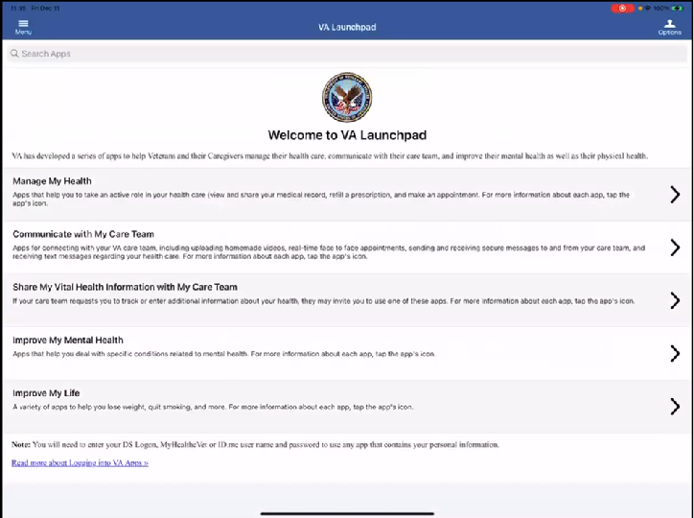

*Participant must have tapped VA Launchpad app*

Launchpad. So I’m looking at a Launchpad. *Participant doesn’t seem to be familiar with this.* Manage my health. *Participant seems to be reading screen*.

*Participant taps on Manage My Health.*

*Participant looks at screen for several seconds.*

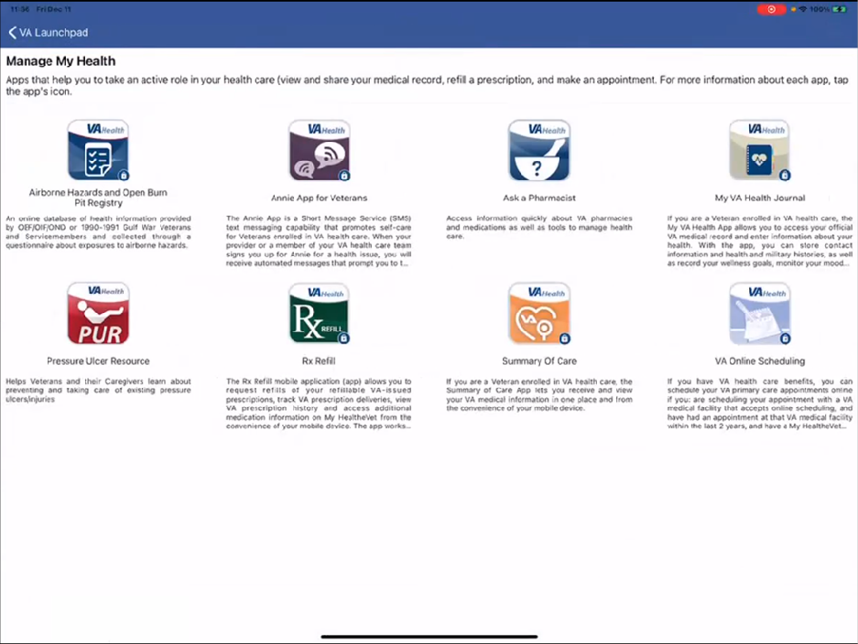

And then I see online scheduling. *Participant doesn’t look very long before finding this.* Let’s see what happens.

*Participant taps VA Online Scheduling*



*Participant taps on Open Application*

Lets see what happens when I click open application.

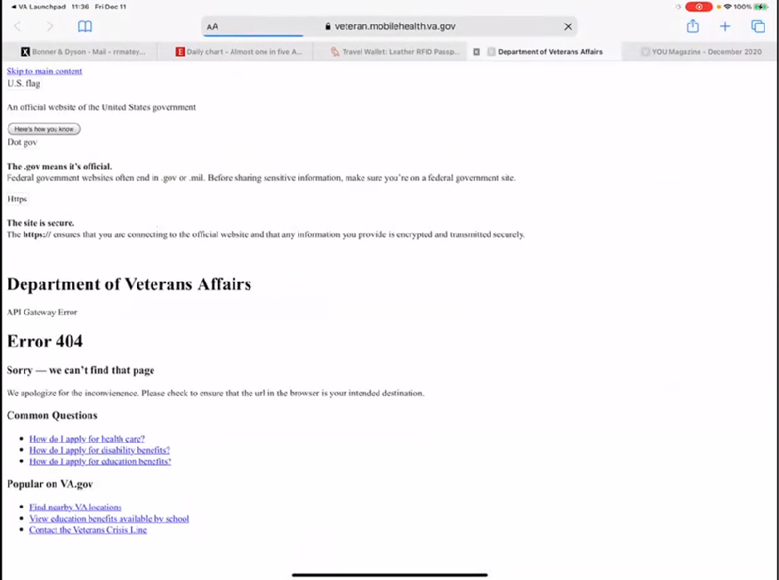

*Open Application opened Safari tab. Page that loads is a 404.*

*Participant scrolls back and forth screen for several seconds.*

Ok so this doesn’t help me much. Since I’m trying to make and appointment for eye care or hearing. I haven’t gotten anything that’s helping me yet. And it’s talking about how do I make an initial application. *Participant doesn’t seem to realize they are on a 404 error page.*

Now I can find nearby VA locations for instance.

*Participant taps on Find nearby VA Locations under Popular on* [VA.gov](http://VA.gov) *heading.*

And that will tell me how to get to Fort Meade.

*Participant taps back to 404 Error page and continues to read it.*

What I’m looking for is the My HealtheVet.

*Participant continues to look at 404 Error page for several seconds.*

I am looking on my iPhone which is going to be very similar. *Participant abandons tablet and uses iPhone, which we can’t see, to figure out next steps. Participant is quiet for several seconds, apparently looking at their phone.*

My next step is to just go online to myhealthevet because I don’t see anything in the app that’s helping me. So I would go online to.

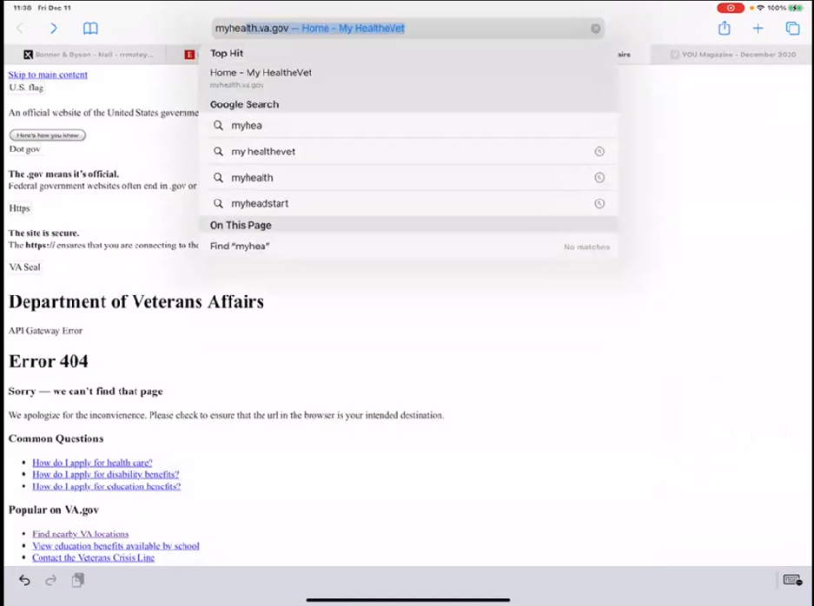

*Participant uses tablet browser to search for myhealthevet.*

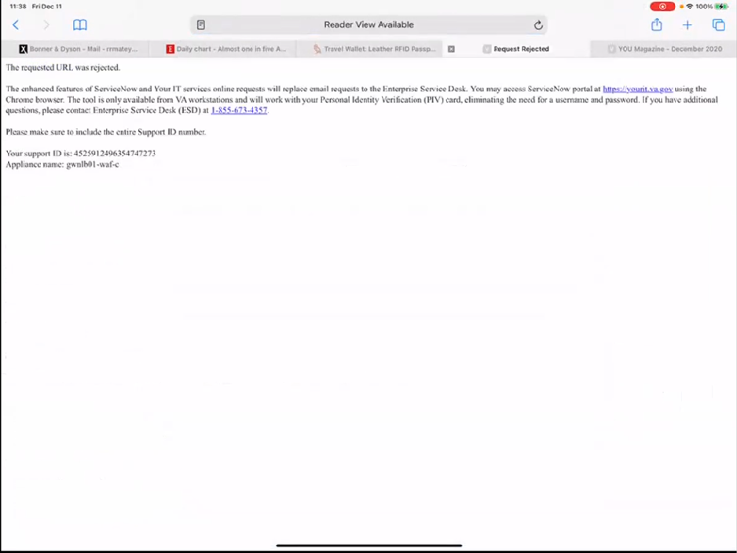

*Participant gets another error page from trying to go to myhealth.va.gov*

*Participant reads error message.* The requested URL was rejected. Ok lets try e health.

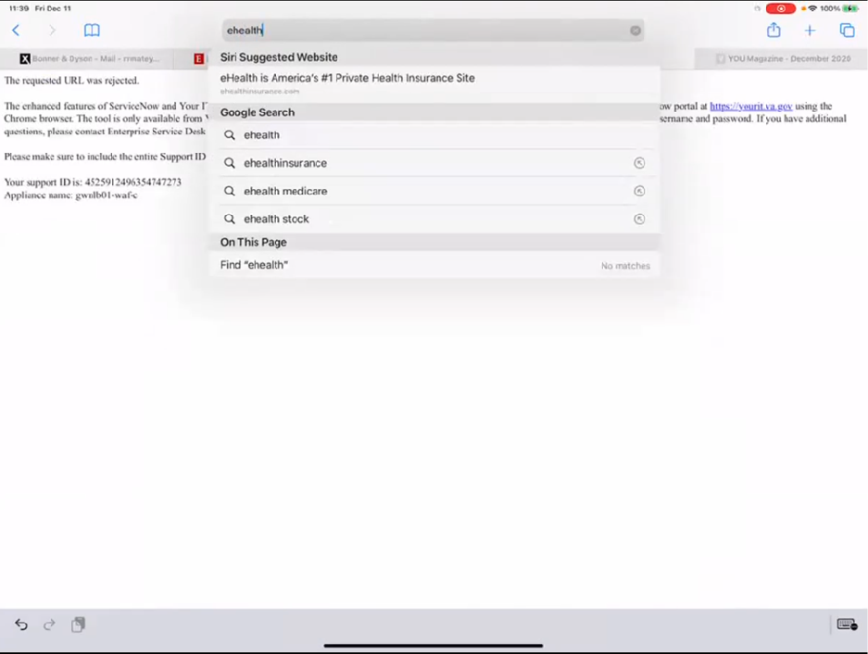

*Participant seems to disregard this just by the suggested Siri and Google Search options in drop down. Never clicks to search the term ehealth*

That doesn’t work. Let’s try my ehealth.

Ok now we have myhealthevet home, so click VA appointments. *Participant taps VA Appointments link in Google Search results.*

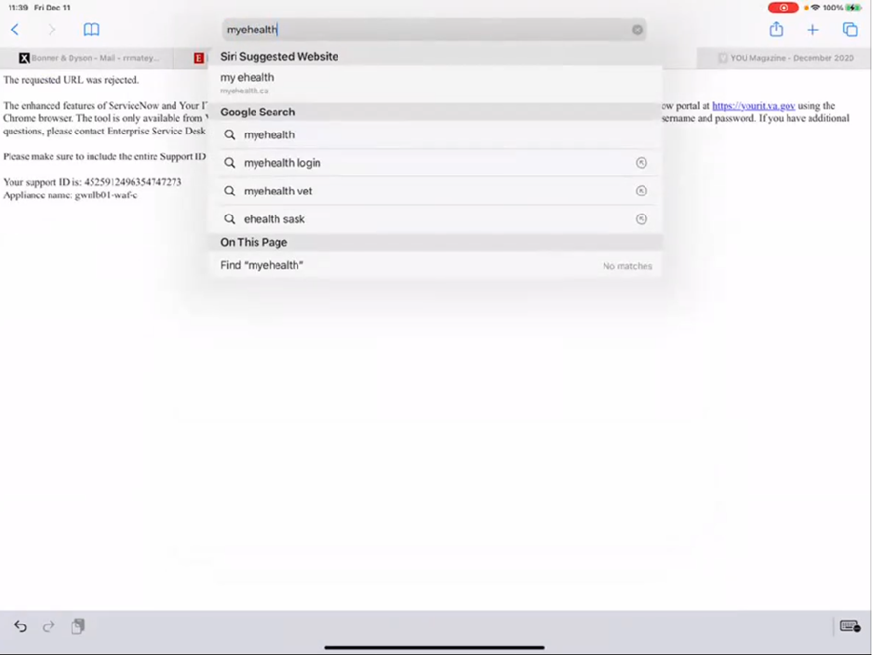

*Participant taps myehealth vet in Google Search options from URL dropdown.*

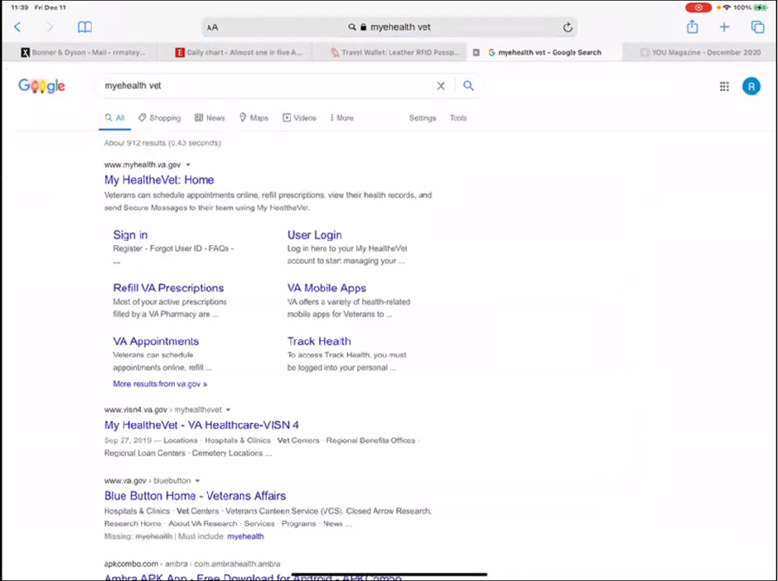

*Participant gets Google search results for myehealth vet*

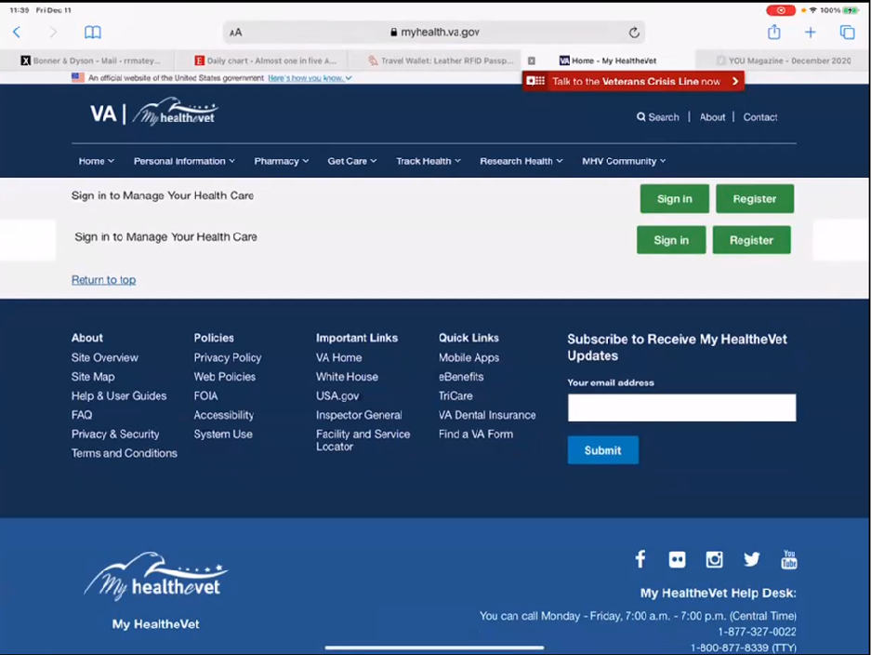

*Page participant gets when tapping VA Appointments from Google search results.*

I have two sign ins here. *Participant taps top “Sign In” button.*

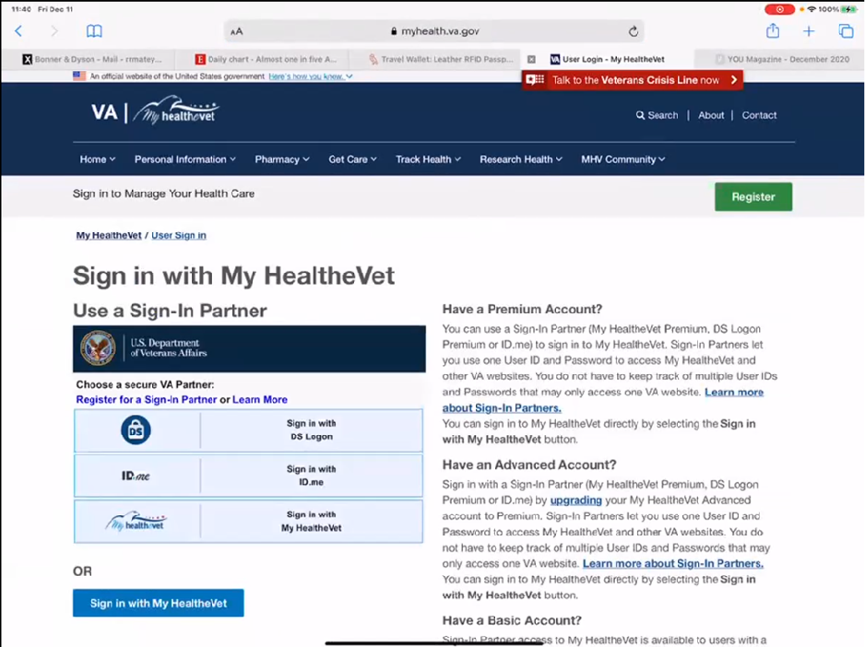

*Participants sign in page.*

My HealtheVet ok. *Participant taps blue “Sign in with My HealtheVet” button.* I think I have a myhealthevet login.

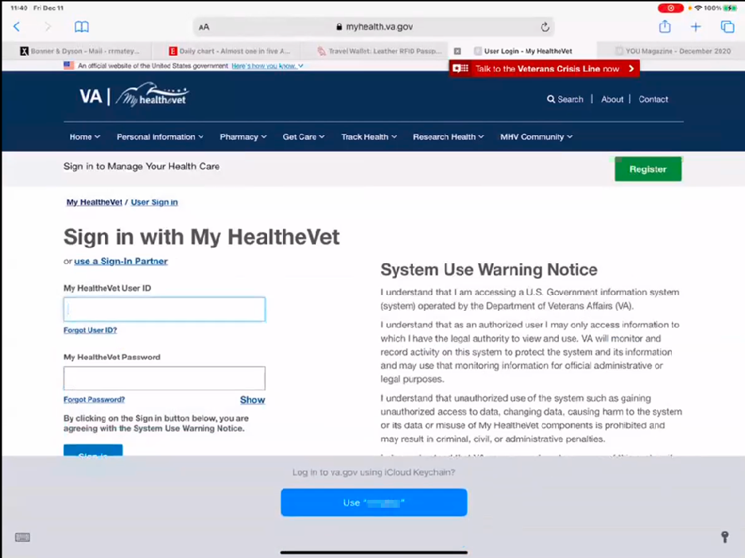

*Participant gets prompted for login from iCloud Keychain, and uses Face ID to verify.*

* **How did you know which login option to choose:**

*Participant chuckles.* They would probably both work. The would both work*.*

* **What’s the other one:**

I’m gonna try to go back. Okay so lets see. *Participant taps browser back arrow all the way to Google Search results, and taps VA Appointments link again.*

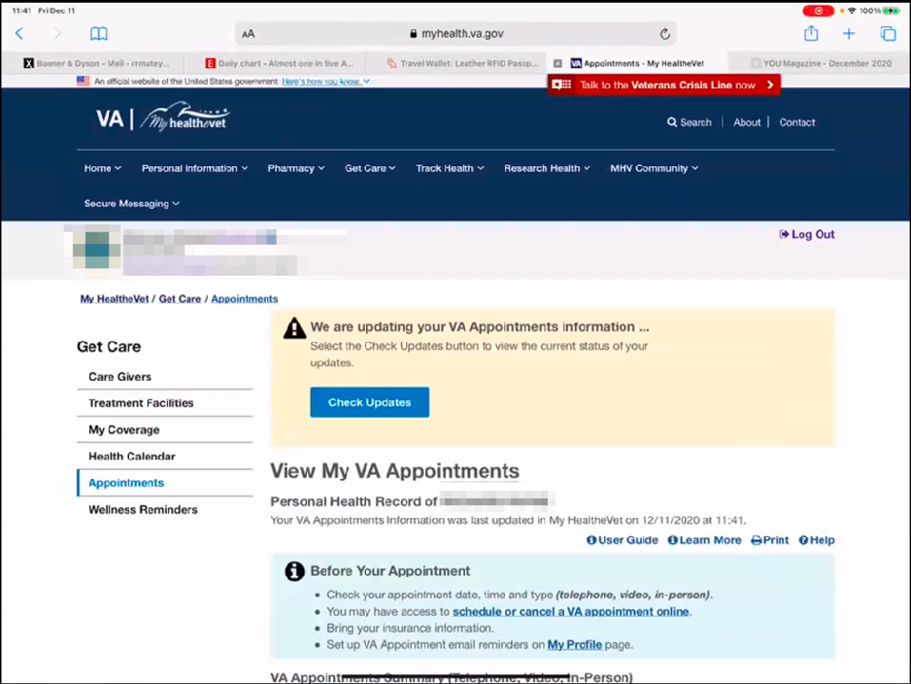

*Browser remembers participant is logged in so loads VA Appointments page.*

It signed me in, the other choice was to use the CAC or DS-something login. I have all of those methods so I could have uses any of them.

I am now viewing appointments. *Participants scrolls down page and looks at table of recent appointments.*

So this is optometry in 2019. I had audiology in December 2019.

*Participant looks at screen for several seconds.*

*Participant chuckles.* Apparently the status of the FM PACT TELE TEAM whatever they are on July 30 was unknown and then cancelled. I don’t actually remember; I think they were going to have an appointment and then cancelled it.

Otherwise that is a pretty good record of my appointments.

* **How would you ask a question:**

I have the number to my doctor so I could call that.

Here it says I can schedule a VA appointment;

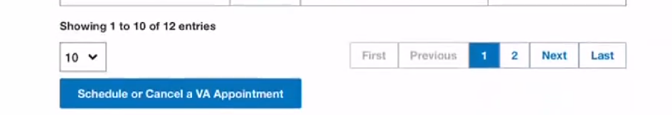

*Participant notices blue “Schedule or Cancel a VA Appointment” button under appointments table. Taps button.*

I wonder if I can schedule an optometry appointment.

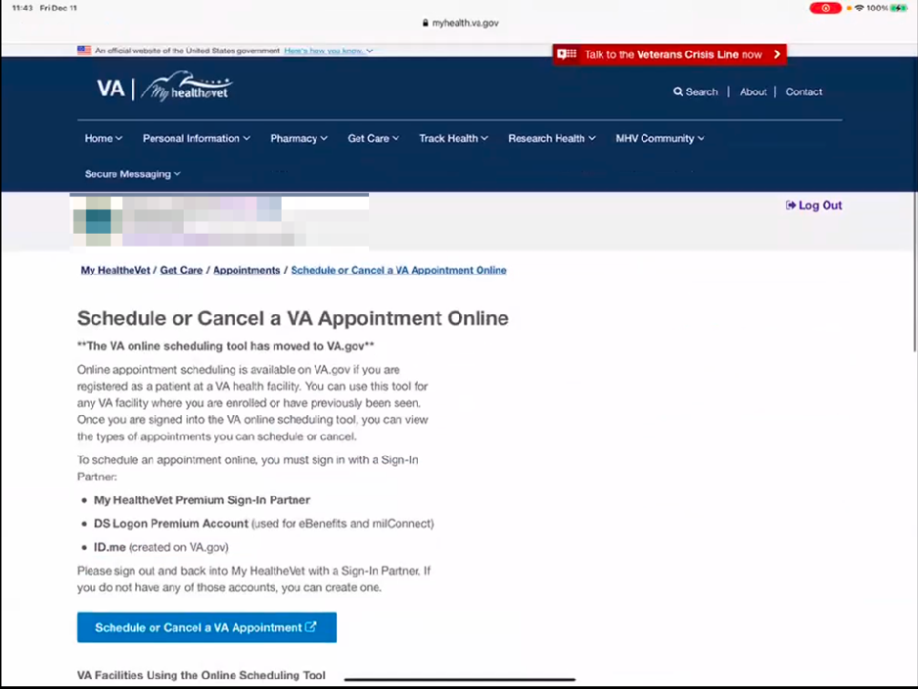

*Participant scrolls through and reads parts of the page out loud.*

It says all sites can do this but you need to sign in. Please sign in and out to do this with a partner if you do not have one you can create one. This is telling me to sign out and sign back in which is a little awkward. So I would have to logout.

*Participant taps “Log Out” link in top right corner of the page.*

Then I can see what happens when I go to appointments now, okay sign in.

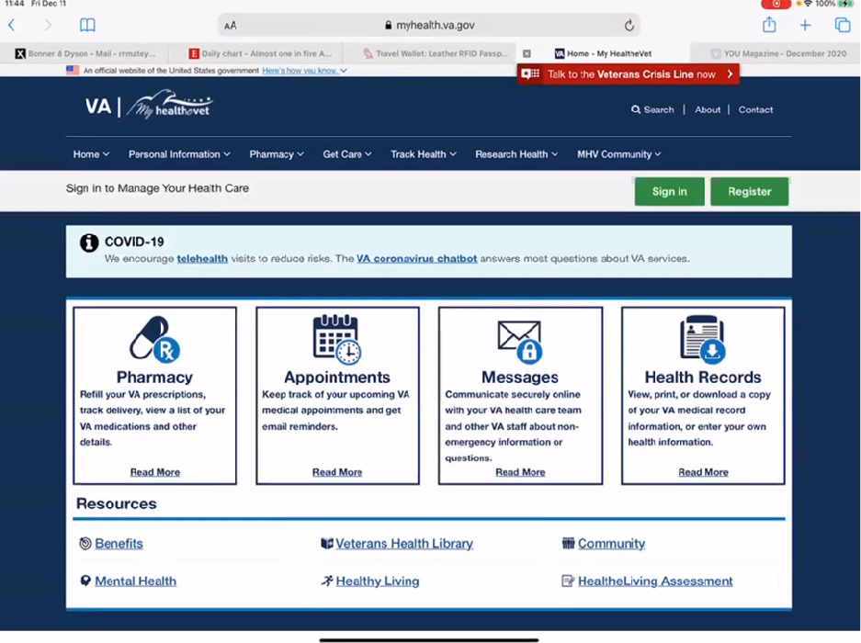

*Participant gets redirected to My HealtheVet home page. Participant taps green “Sign In” button at top right of page.*

I would sign in the same way I did before. *Participant signs in again and audibly sighs.*

Now view my schedule. Participant taps “Schedule a VA Appointment” link.

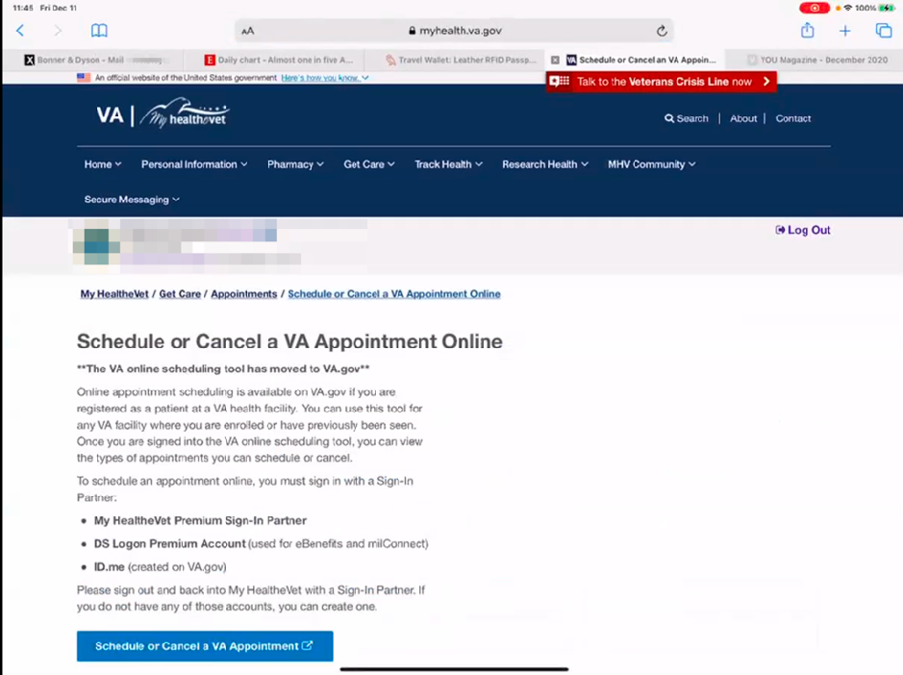

*Participant chuckles looking at this page.*

Then it looks like I am in a loop now because I am back to the page where it says sign out.

Wait a minute I will click schedule appointment.

*Participant clicks blue “Schedule or Cancel a VA Appointment” button.*

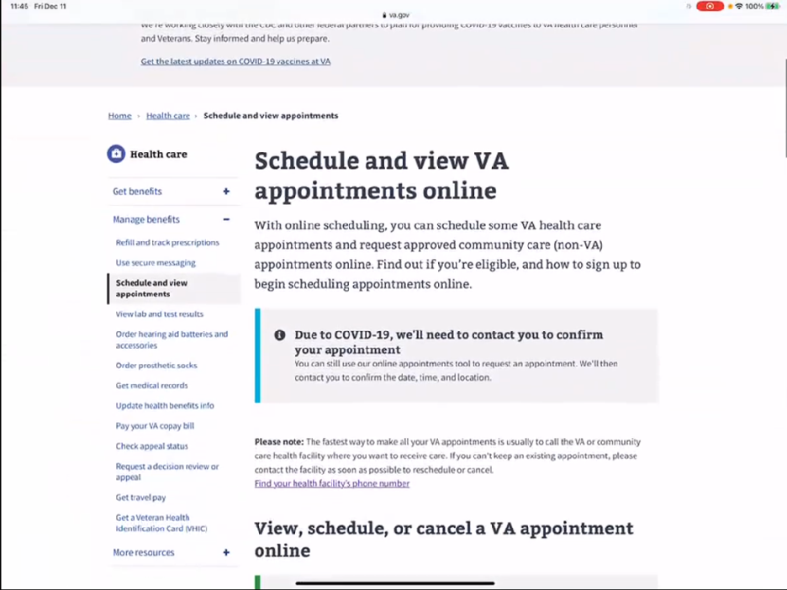

*Participant gets redirected to [VA.gov](http://VA.gov) page.*

It is still working.

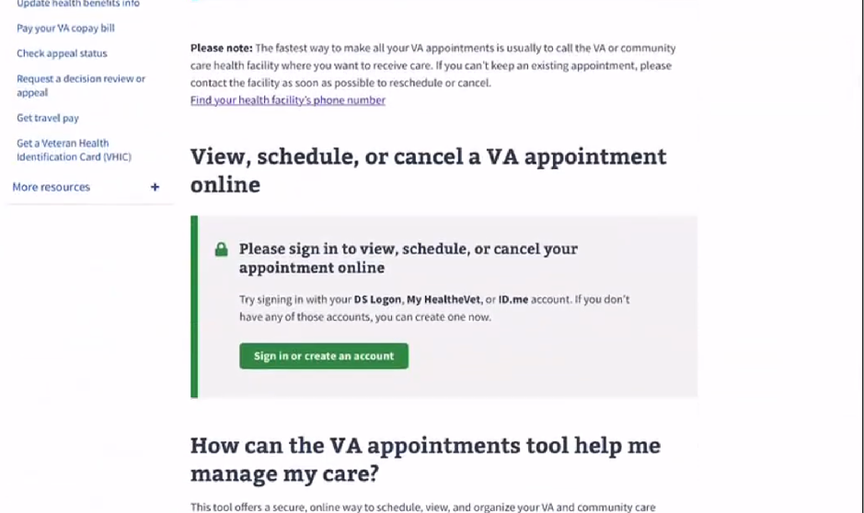

*Participant scrolls down page.*

Please sign in to view, schedule or cancel the appointment.

I am getting confused because I signed in twice already.

* **What do you think the green sign in button would do if you were to click it:**

It would provide the opportunity to sign in one more time. Or I could create an account. *Participant taps green “Sign in or create and account” button.*

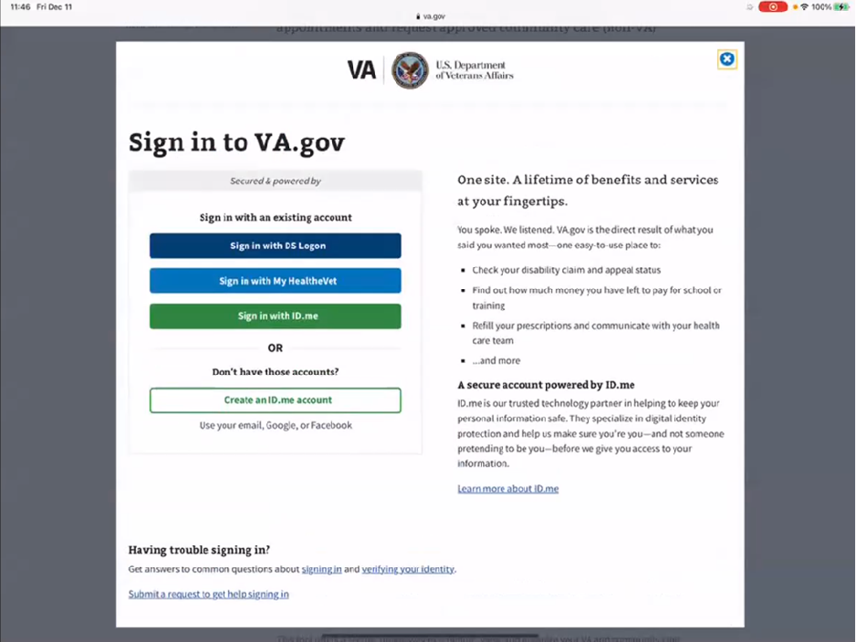

*Participant gets directed to [VA.gov](http://VA.gov) sign in page and taps “Sign in with My HealtheVet” button*

I am being redirected.

* **Which did you sign in with:**

The same option as myhealthevet.

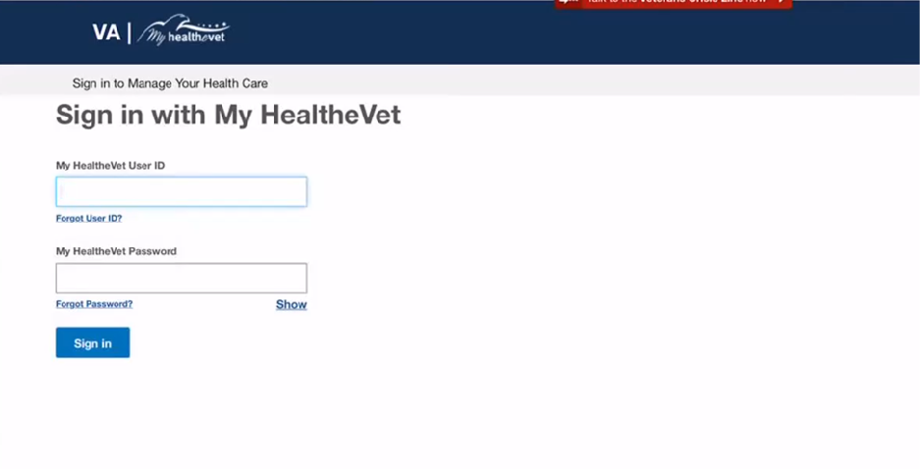

*Participant gets directed to sign in again.*

This is my third time signing in now.

*Participant signs into My HealtheVet.*

Lets see. Oh now to complete the sign in this is new.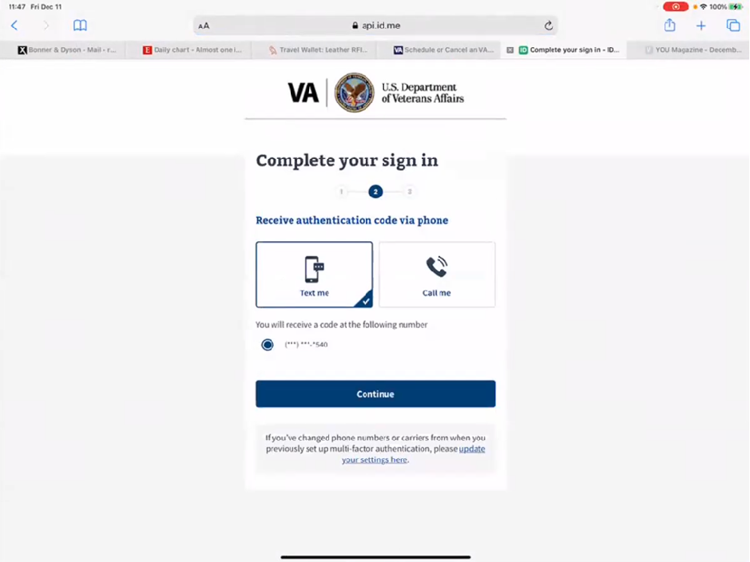

It will send a code to my phone after I press continue.

Here is the code.

*Participant enters code into sign in.*

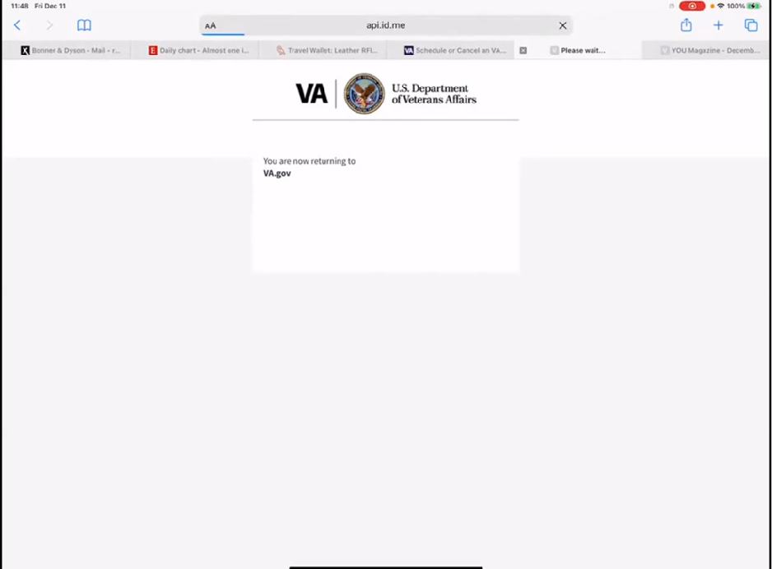

*Page loads for ~ 30 seconds.*

* **What is happening now:**

It looks like it is spinning circles as it is taking me to VA.gov.

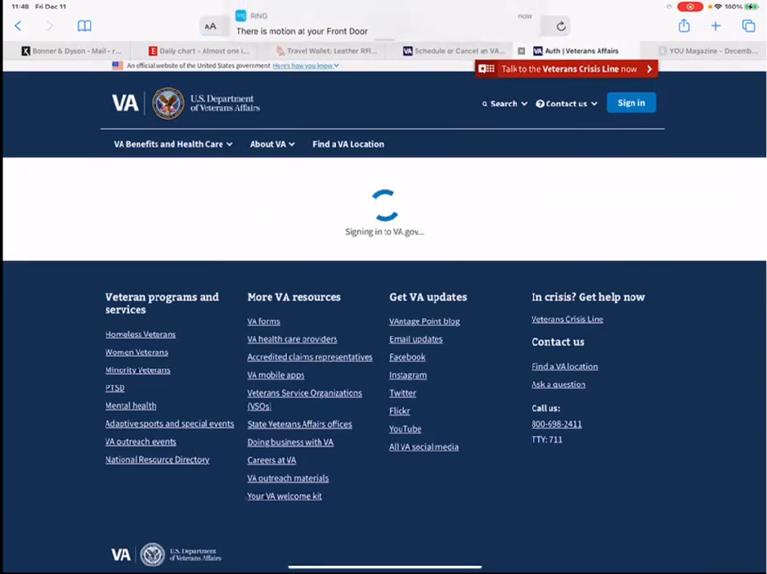

Now it is getting closer. Says it’s signing into VA.gov.

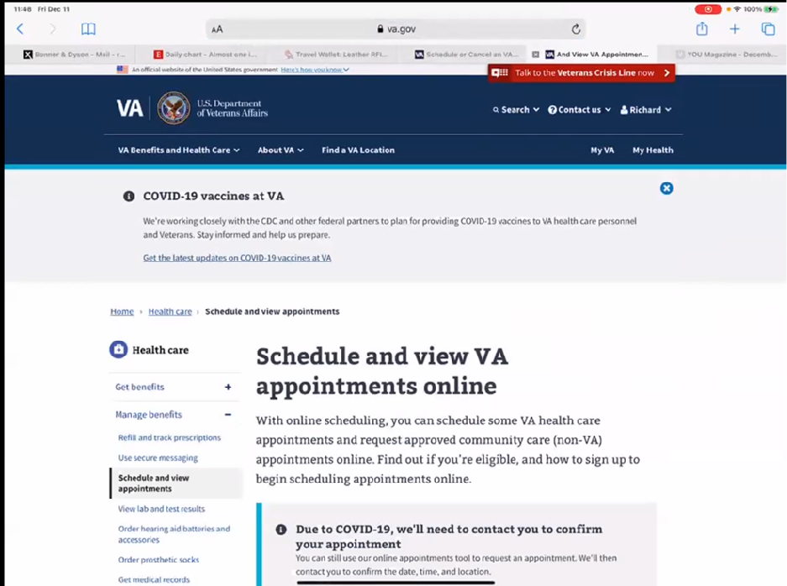

*Participant chuckles when page finally loads.*

It seems like we’ve been here before.

*Participant scrolls down page.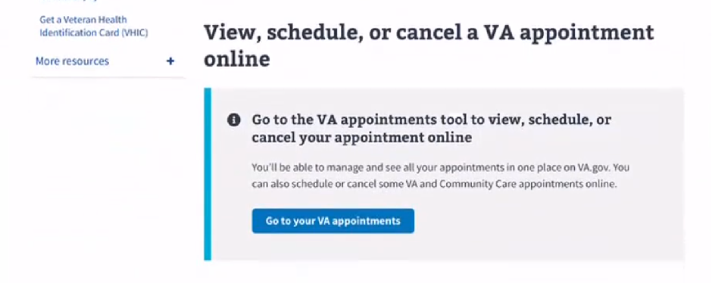*

This time it says go to VA appointments to see and schedule the appointment.

I don’t see the lock up there anymore so I would go to VA appointments.

*Participant taps blue “Go to your VA appointments” button.*

It says welcome to the VA scheduling tool.

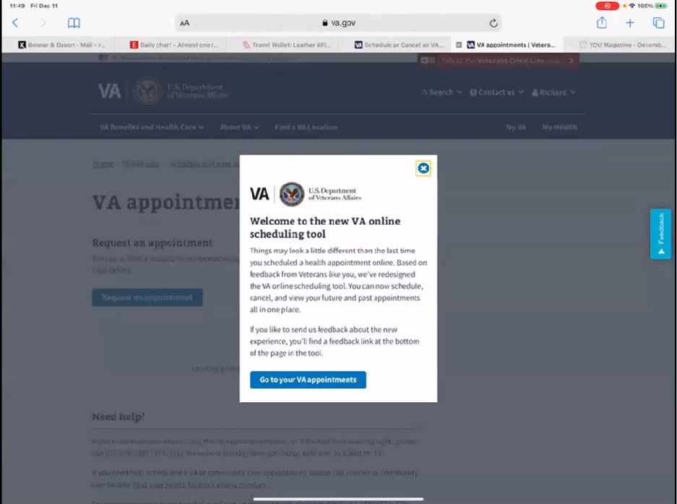

*Participant taps “Go to your VA Appointments” button.*

It looks like I broke into the system now.

*Participant reads page.*

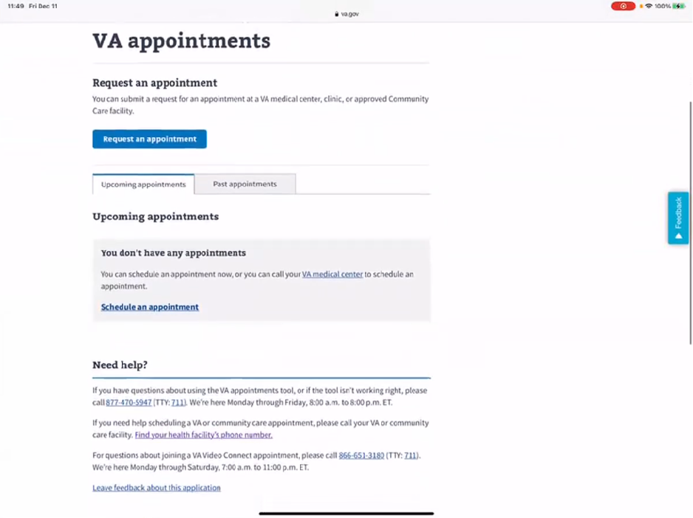

*Participant taps blue “Request and appointment” button.*

Request appointment. So I need eyecare.

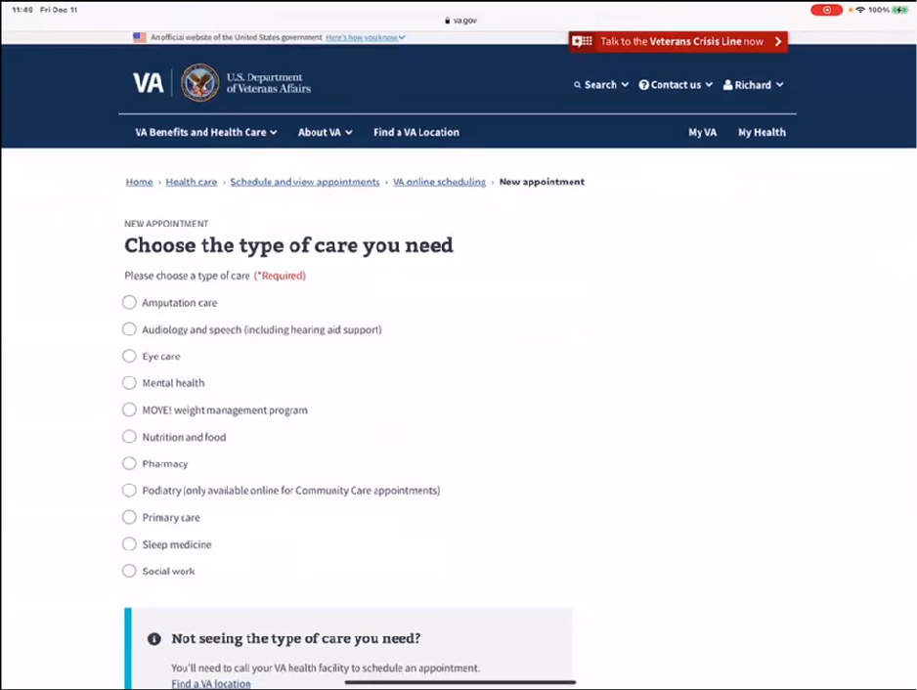

*Participant selects “Eye care” and taps “Continue” button.*

Now this is confusing.

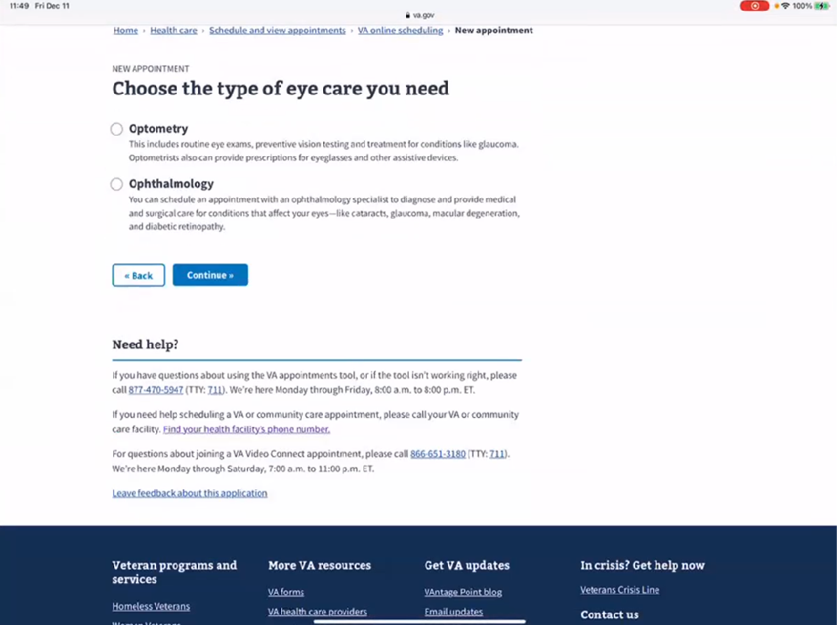

*Participant reads description on page, selects “Optometry” and taps “Continue” button.*

* **Was the text below helpful to choose between two:**

The choice between them I choose optometry.

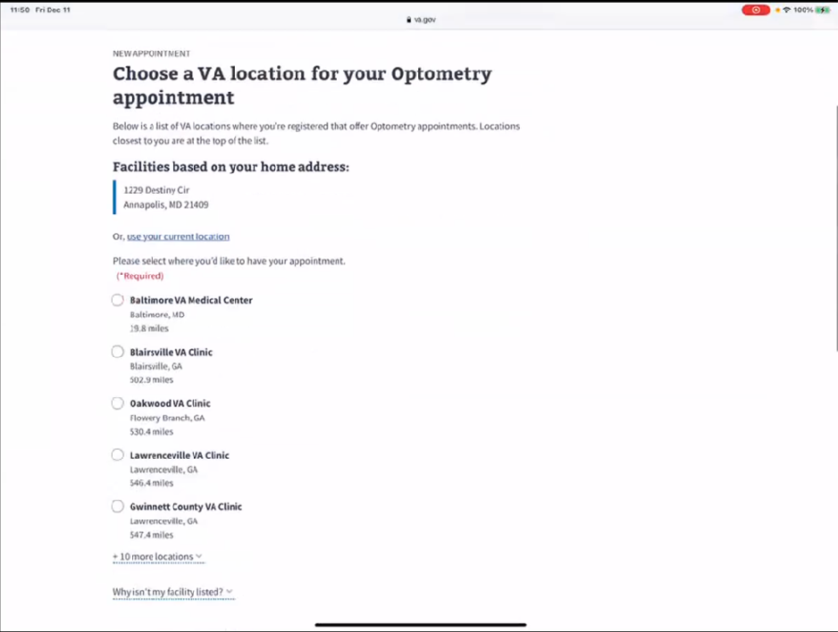

It is finding locations.

Apparently I could go to Baltimore because they are not doing it at Fort Meade.

* **Making appointment:**

*Participant reads through options on page, selects a location, and taps “Continue” button.*

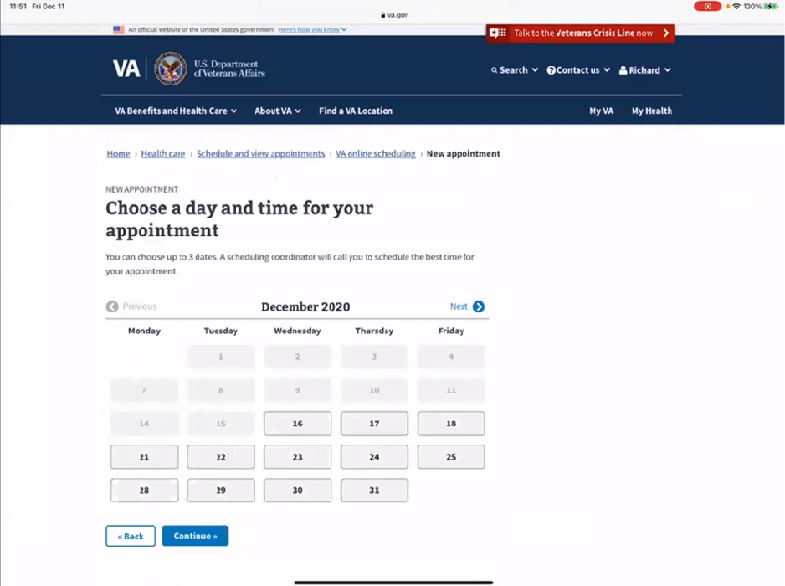

Let me look at my calendar to see. I will try 18, 21, 22. All of them will be PM because they are further away.

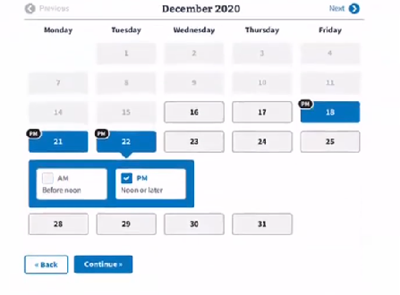

*Participant taps 18 PM, 21 PM, 22 PM and taps “Continue” button.*

*Participant reads page out loud to self*. It is a routine visit. Enter eyesight is changing.

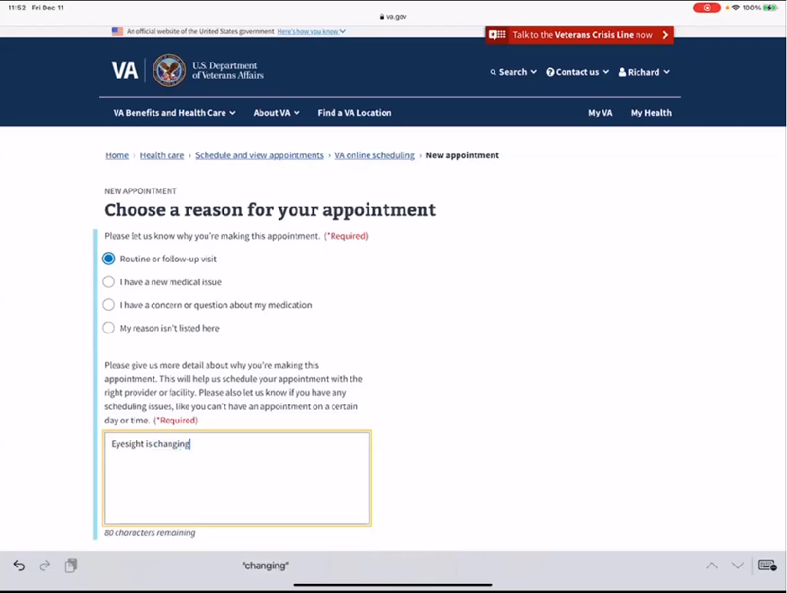

*Participant selects “Routine or follow-up visit”, enters “Eyesight is changing” in text box requiring more detail, and taps “Continue” button.*

I think this requires an office visit.

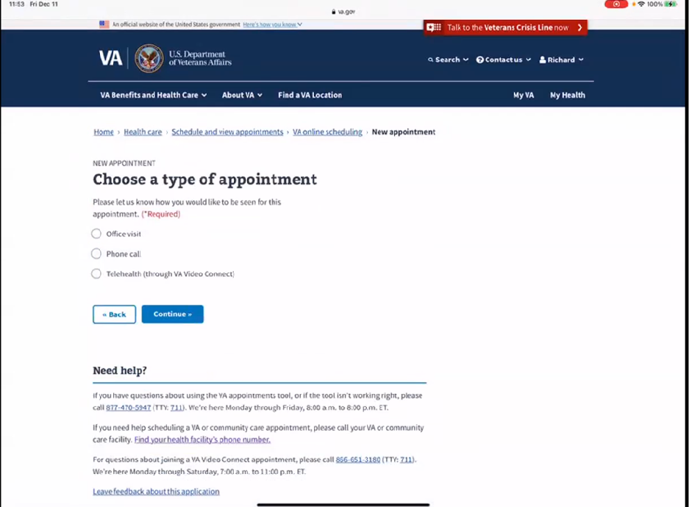

*Participant selects “Office visit” and taps “Continue” button.*

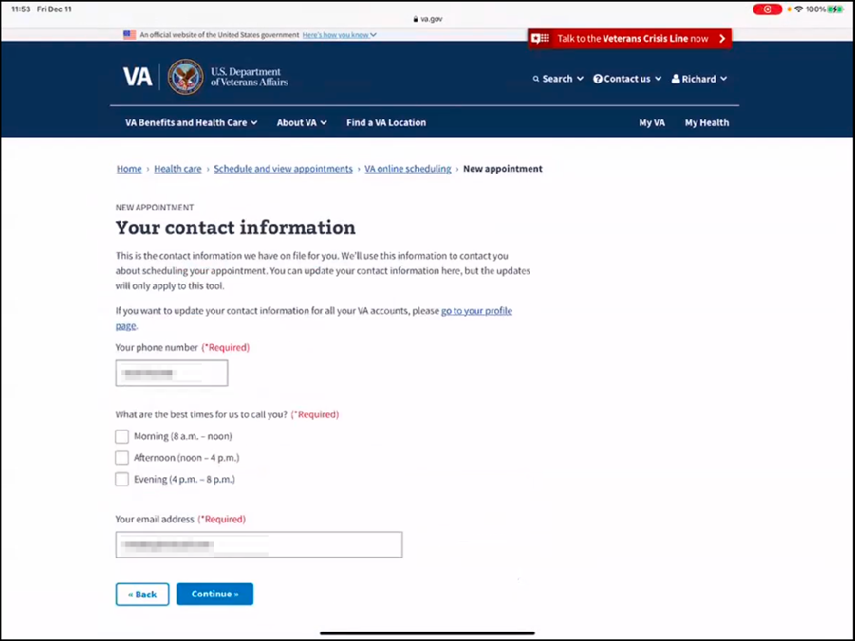

*Participant reads page. Phone number and email was already filled in. Participant selects “Afternoon”, and taps “Continue”.*

*Participant reads Review your appointment details page, and taps “Request appointment” button.*

Okay so click request the appointment. I assume someone will call me and tell me what fits their schedule.

* **Have you used this before to schedule the appointment**:

No.

**Branding and trust (5 minutes)**

Now I’d like to ask for your thoughts on My HealtheVet. (Confirm that participant has used My HealtheVet previously. If not, amend questions below to capture their first impressions while looking at a logged in account.)

1. **On a scale from 1-5, with 1 being very dissatisfied, and 5 being very satisfied, how satisfied are you with My HealtheVet**

I would rate it as a 4.

1**.a. What makes you rate it a 4?**

I had to sign in 4 times to get to the process I was looking for. Once I was signed in the process worked and I could follow it but it is aggravating to get to the part to start working.

1. **On a scale from 1-5, with 1 being very low, and 5 being very high, how would you rate your trust in My HealtheVet?**

Oh I trust them. 5.

**2.a. What makes you rate it a 5?**

I know they are working hard and I know through this process, I have been on more then one of these type of surveys so I know they are working hard to make the system work. So I appreciate that.

**My HealtheVet patient portal (15 minutes)**

1. **What do you use My HealtheVet website for the most?**

At this point I can get my lab test results through myhealthevet and this is useful for the once a year PSA tests with the VA.

I do the PSA testing twice a year for my urologist under the watchful waiting program. They don’t want it to start acting up without knowing.

Once a year for the VA then twice a year for the urologist.

1. **What do you find the most important thing My HealtheVet?**

I guess just the fact that I can look up my records is the most important.

1. **Why is that:**

Well if something changes I want to go back and find out what my record showed prior to the change.

**Thank you and closing (2 minutes)**

**Any feedback:**

No, I mean I think I am doing okay and I don’t have any questions at this time.